Cs 308

Keith Wheeler

This is written for the general public to give a general understanding of the creative process behind programming.

# The Design Process and Design Documents

Designing is a process of writing down a problem, then mapping out the solution. In programming, the page is called a Design Document. A typical problem would be a real life dilemma, like listening to free music, and creating a program to fix the problem. Pandora is a website that caters to this problem. It has an algorithm that takes in your choice of song or artist, and puts out music that is comparable. To make a Design Document for this problem, the first step is to write down the focus of the problem. In this case it is to listen to music that you prefer without having to do all the research yourself. The second step is to write down the solution which is to create a website that will take in your choice of what to listen to, and put out songs that are similar. The third step is to show how the interface will look by creating a picture of what the page will look like. Fourth is to write down a chart that lists all the required aspects of the program to be written. The last few steps include Algorithms, Data Structures, File Formatting, and Error Handling, which are used by the programmer to know how the program will act and function as a whole. Below is an example of a Design Document that I wrote for a Moon Lander game. It is not a perfect example, but includes the necessary components in order to recreate the game.

Keith Wheeler

CS - 165 Comeau

Project 2 – MoonLander

Design Overview – The program will draw the ground, platform, and lander then allow the player to use the left, right, and bottom thrusters to land on the platform.

Interface design -

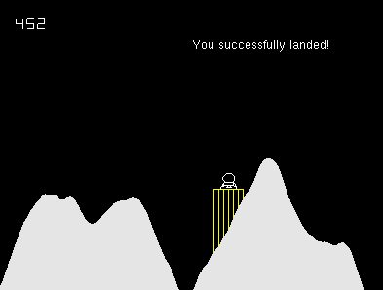

Data structures –

All bools will be either true or false, therefore you are either dead or not, you landed or you crashed.

Int fuel will keep track and display the used fuel. It will start from 500 and count down.

Int xSize will help display the ground.

Float x and Float y keep track of where the lander is on the screen compared to the ground, platform, and edge of the screen.

